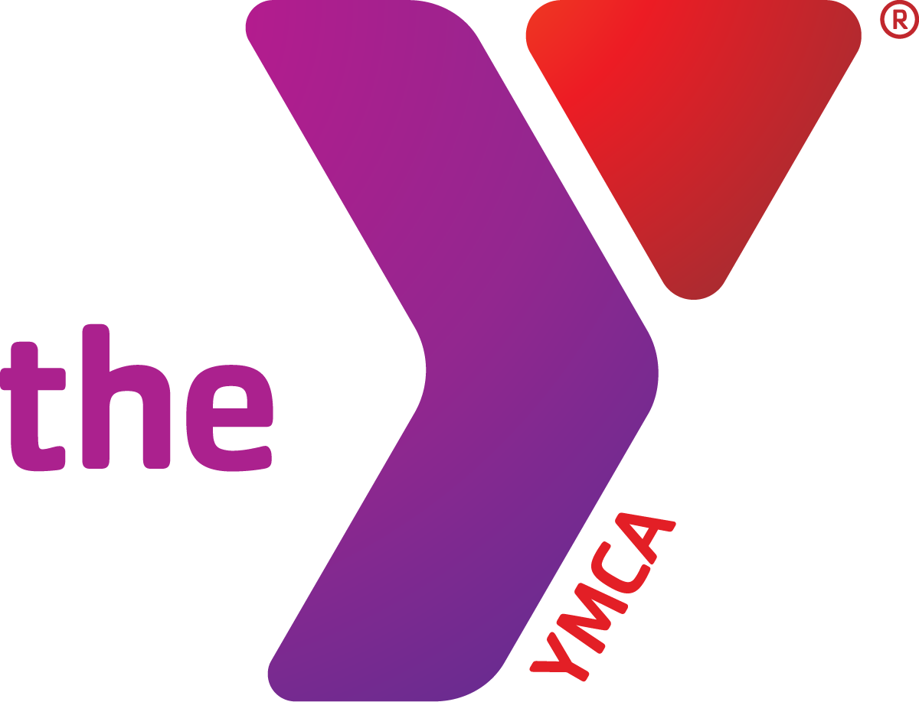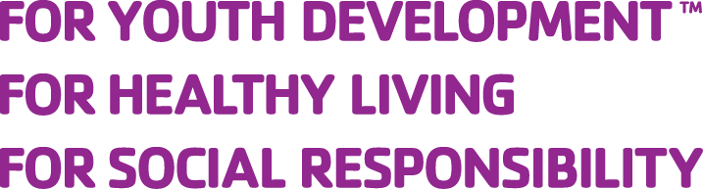
Bayview Hunters Point YMCA
Jr. NBA Basketball League 2016-17
Registration Form

Today’s Date: _________________

Youth Name: Date of Birth: ____ /____ /____ (mo./day/yr.)

School in 2016-17: Grade in 2016-17: Gender: □ M □ F

Participant’s Cell: _ _ Is this child an English Language Learner? □ Y □ N

T-Shirt Size: Free Lunch Eligible? □ Yes □ No Reduced Lunch Eligible? □ Yes □ No

Ethnicity/Race (check one):

□ Asian / Pacific Islander □ African American □ Alaskan Native □ Hispanic

□ Native American □ Caucasian / White □ Other □ Decline

Preferred Home Language (check one):

□ English □ Spanish □ Cantonese □ Mandarin/Putonghua

□ Vietnamese □ Khmer/Cambodian □ Pilipino/Tagalog □ Other (specify):

Adult 1 Name: Relationship: _

Cell: OK to send text? □ Yes □ No Home Phone Number:

Address: City: Zip Code:

Date of Birth: / / (mo./day/yr.) Email: _

Adult 2 Name: Relationship: _

Cell: OK to send text? □ Yes □ No Home Phone Number:

Address: City: Zip Code:

Date of Birth: / / (mo./day/yr.) Email: _
Emergency Contacts (other than parents(s) / guardian(s) listed above):

Name: Relationship: Cell Phone: _

Name: Relationship: Cell Phone: _

How your child will get home from the program (check all that apply):

□ Alone □ Only with parent indicated below □ Others I may specify over the phone (emergencies only)

□ With one of the following authorized individuals:

Name:______________________________ Phone:___________________________________

Name:______________________________ Phone:___________________________________
Medical Information

Is there any medical information we should have about your child (e.g. allergies, asthma, etc.)?

□ Yes □ No If yes, please describe: _______________________________________________________________

_____________________________________________________________________________

Does your child regularly take any prescribed medication?

□ Yes □ No If yes, please describe: _______________________________________________________________

_____________________________________________________________________________

Does your child require special accommodations?

□ Yes □ No If yes, please describe emotional, behavioral, physical, and/or other special needs:

_____________________________________________________________________________

Additional Information

Is there anything else you would like us to know about yourself or your child?

_____________________________________________________________________________

_____________________________________________________________________________

_____________________________________________________________________________

_____________________________________________________________________________

_____________________________________________________________________________

_____________________________________________________________________________

Photo Waiver
I, ____________________________, give the YMCA of San Francisco and its affiliate branches full

permission to use photos of myself or my child(ren) for use in media materials, external collateral pieces (mailers, brochures, fundraising, appeals, etc.), promotional video pieces, social media platforms (Facebook, Instagram, Pinterest, Twitter, etc.) and Web sites of the YMCA of San Francisco and its affiliate branches.

I understand that the YMCA of San Francisco and its affiliate branches may attempt to notify me of the use of any images, interviews and other materials I have provided, but that I may not be notified in advance if anything I have provided is chosen for use in public materials.

Printed Name: _____________________ Signature: ____________________ Date: _________

Authorization of the Release of Information

I,_________________________________, declare that I am the parent/legal guardian of,

__________________________________, and I give permission to the Bayview Hunter’s Point

YMCA staff to access my child’s academic school records and to collect all information necessary to support her/his academic achievement. I understand that information may be shared within the agency for the purpose of consultation in order to provide the best quality of care. I also understand that the YMCA of San Francisco will keep these records confidential in keeping with the YMCA of San Francisco Privacy Statement.

Printed Name: _____________________ Signature: ____________________ Date: _________
Walking Permission Form

I, ____________________________, do hereby give permission for my child,

____________________________ to leave the Bayview YMCA and its affiliate locations (Carver

Elementary School, Willie Brown Middle School, Martin Luther King, Jr. Middle School and Phillip & Sala Burton High School) on his/her own, or to be left at the drop off location, without a parent/guardian picking him/her and signing for the child. He/she will be signing him/herself out and thus releasing the YMCA’s liability of supervision once they have signed out. The child must be at least 10 years old. An older child is NOT allowed to take a child under 10 years old away from the YMCA unless there is a separate form completed for the younger child specifically indicating that this child will be chaperoned home by the specified older child and this older child MUST be a sibling.

Children will not be released to leave on their own unless this form has been completed by a parent/guardian. This form should be completed in front of a YMCA staff person. If the parent does not complete this form in the presence of a YMCA staff person, a follow-up call will be made by the YMCA to confirm the intent of the parents/guardians.

In signing this form, I do hereby agree to hold free from any and all liability the Bayview YMCA and its respective officers, employees, volunteers, and members, and do hereby for myself, my heirs, executors and administrators, waive and release and forever discharge any and all rights and claims for damages which I may have hereafter accrued to me arising out of or in connection with my child’s participation in any of the activities of the Bayview YMCA.

Printed Name: _____________________ Signature: ____________________ Date: _________
Code of Conduct for Personal Safety

YMCA Youth and Teen programs are designed to provide safe enriching opportunities for young people in a variety of settings. The YMCA attempts to build a safe environment with “ground rules” that always include the character values of honesty, respect, responsibility, and caring. Every person has the right to feel emotionally and physically safe while participating in programs. A high level of positive conduct is expected of all participants. Both youth and adults shall observe the Code of Conduct. There is no double standard.

Basic Philosophy of Responsible Conduct:
- Everyone is responsible for their own behavior.
- Everyone will act responsibly to sure that their own attitude is beneficial not only to themselves and their fellow participants, but also to ensure the continuation of YMCA youth and teen programs.
- Those who decide to be present when the violation occurs shall, by their own choice, be considered a participant in the violation. There are no innocent bystandards.

Infraction of the following code of conduct can result in expulsion from program.

To ensure a safe environment, youth and adults must:
- Treat all persons in and around program with mutual respect and without discrimination based on gender, sexual orientation, size, shape, religion, culture, and socioeconomic difference. There is no tolerance for bullying.
- Be a responsible ally to all those in and around program who may be experiencing discrimination.
- Staff will keep conversations in confidence unless person(s) are in danger of harming themselves or others or is treated as such.
- Any act of vandalism, theft, destruction of property, or misuse of a facility may be an infraction and will be treated as such.
- Intimate sexual behaviors are not allowed. This includes inappropriate and uninvited physical contact between participants, staff members, or guests.
- Possession and or consumption of alcoholic beverages and illegal drugs are strictly prohibited.
- Smoking and/or the use of any tobacco products is not permitted.
- Weapons of any kinds and items that could cause injury or damage to participants and our property are strictly forbidden.
- Activities that endanger the health and safety of yourself or others are unacceptable.
- Strive to be examples to peers and community in core values of honesty, respect, responsibility, and caring.

In the case of a serious incident involving youth participation in Sex, Smoking, Drugs, Alcohol (SSAD RULE), or acts that endanger the health and safety of the participants, Parents/Guardians will be expected to pick me up, or pay for my transportation home, and no fee refund will be issued. All expenses and arrangements related to any disciplinary action are the sole responsibility of the participant’s family.

I have read and agree to abide by the condition of the Code of Conduct.
___________________________________ ___________________________________ Participant’s Signature Date Parent’s/Guardian’s Signature Date

YMCA OF SAN FRANCISCO MEMBERSHIP APPLICATION
Release and Waiver of Liability and Indemnity Agreement

IN CONSIDERATION of being permitted to utilize the facilities, services and programs of the YMCA (or for my children to so participate) for any purpose, including, but not limited to observation or use of facilities or equipment, or participation in any off-site program affiliated with the YMCA, the undersigned, for himself or herself and such participating children and any personal representatives, heirs, and next of kin, hereby acknowledges, agrees and represents that he or she has, or immediately upon entering or participating will, inspect and carefully consider such premises and facilities or the affiliated program. It is further warranted that such entry into the YMCA for observation or use of any facilities or equipment or participation in such affiliated program constitutes an acknowledgment that such premises and all facilities and equipment therein and such affiliated program have been inspected and carefully considered and that the undersigned finds and accepts same as being safe and reasonably suited for the purpose of such observation, use or participation by the undersigned and such children.

IN FURTHER CONSIDERATION OF BEING PERMITTED TO ENTER THE YMCA FOR ANY PURPOSE INCLUDING, BUT NOT LIMITED TO OBSERVATION OR USE OF FACILITIES OR EQUIPMENT, OR PARTICIPATION IN ANY OFF-SITE PROGRAM AFFILIATED WITH THE YMCA, THE UNDERSIGNED HEREBY AGREES TO THE FOLLOWING:
- THE UNDERSIGNED, ON HIS OR HER BEHALF AND BEHALF OF SUCH CHILDREN, HEREBY RELEASES, WAIVES, DISCHARGES AND COVENANTS NOT TO SUE the YMCA, its directors, officers, employees, and agents (hereinafter referred to as “releasees”) from all liability to the undersigned or such children and all his personal representatives, assigns, heirs, and next of kin for any loss or damage, and any claim or demands therefor on account of injury to the person or property or resulting in death of the undersigned, whether caused by the negligence of the releasees or otherwise while the undersigned or such children is in, upon, or about the premises or any facilities or equipment therein or participating in any program affiliated with the YMCA.
- THE UNDERSIGNED HEREBY AGREES TO INDEMNIFY AND SAVE AND HOLD HARMLESS the releasees and each of them from any loss, liability, damage or cost they may incur due to the presence of the undersigned or such children in, upon or about the YMCA premises or in any way observing or using any facilities or equipment of the YMCA or participating in any program affiliated with the YMCA whether caused by the negligence of the releases or otherwise.
- THE UNDERSIGNED HEREBY ASSUMES FULL RESPONSIBILITY FOR AND RISK OF BODILY INJURY, DEATH OR PROPERTY DAMAGE to the undersigned or such children due to negligence of releasees or otherwise while in, about or upon the premises of the YMCA and/or while using the premises or any facilities or equipment thereon or participating in any program affiliated with the YMCA.
- THE UNDERSIGNED HEREBY GIVES PERMISSION for the YMCA of San Francisco, or any of its branches, to use any photographs or video footage taken of the undersigned and/or the undersigned’s children participating in YMCA of San Francisco activities for future YMCA promotional purposes, including without limitation, media materials, promotional print pieces, promotional video pieces, social media platforms and Web sites of the YMCA of San Francisco and its affiliate branches, without additional release or authorization.
- PARTICIPATION: I give permission for my child to participate in all activities associated with the program, including off-site field trips.

THE UNDERSIGNED further expressly agrees that the foregoing RELEASE, WAIVER AND INDEMNITY AGREEMENT is intended to be as broad and inclusive as is permitted by the law of the State of California and that if any portion thereof is held invalid, it is agreed that the balance shall, notwithstanding, continue in full legal force and effect.

THE UNDERSIGNED HAS READ AND VOLUNTARILY SIGNS THE RELEASE AND WAIVER OF LIABILITY AND INDEMNITY AGREEMENT, and further agrees that no oral representations, statements or inducement apart from the foregoing written agreement have been made.

I HAVE READ THIS RELEASE.

Signature of applicant/parent: ______________________________ Date: ____ /_____ /____

Print name of applicant/parent: __________________________________________________

Print name(s) of child(ren) in program: ____________________________________________

